How to Enable Lockdown Browser and/or Monitor for Assessments
In order to turn on the Respondus Lockdown Browser and/or Respondus Monitor, you must have already created your quiz in D2L. After you have created the quiz, follow these steps to enable Respondus LockDown Browser and/or Respondus Monitor for your selected quiz.
- Using a standard web browser, log into D2L as an instructor. Select the course you want to manage.
- In the course, click on “Assessments.” Click “Quizzes” from the dropdown menu.
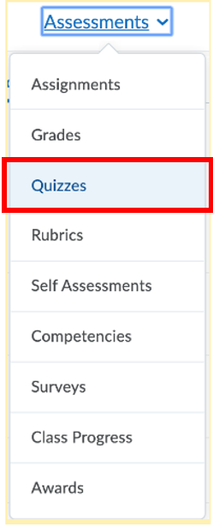
- On the “Quizzes” page, click “LockDown Browser Dashboard” near the top of the screen.

Note: If this is your first time using LockDown Browser settings, you may receive a notification that Respondus Inc is trying to access your information. Click “Continue” to proceed. A video may also appear; you can watch the clip or click “Continue to LockDown Browser” to proceed.
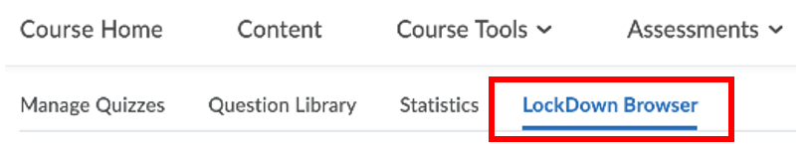

- A list of the quizzes in your course and their current settings for LockDown Browser and Respondus Monitor will be displayed. Identify the quiz where you want to modify the settings. Click the downward-facing arrow to the left of the quiz title.
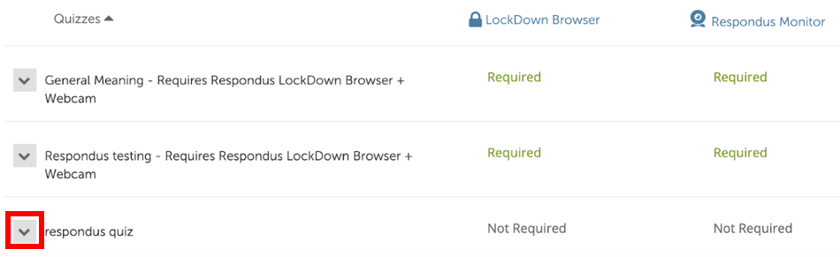
- Click “Settings” from the dropdown menu.
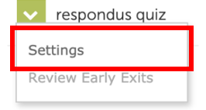
- A menu will drop down and prompt you to decide whether or not to require Respondus LockDown Browser for the exam. Click “Require Respondus Lockdown Browser for this Exam.”
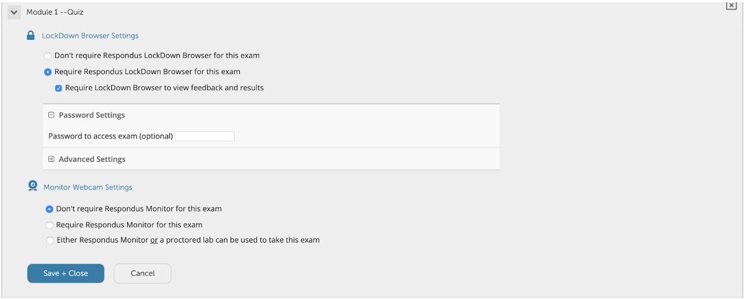
- The menu will drop down further to provide you with an array of options for enabling LockDown Browser and Monitor Webcam settings. Further explanation of some of these menu options is included below:
  - For LockDown Browser:
    - You may additionally require that LockDown Browser be used for students to view feedback and results.
    - Password Settings: If desired, you may create a password that students must enter in order to start the quiz.
  - For Monitor Webcam Settings
    - LockDown Browser must be enabled in order to require or use Monitor Webcam settings
    - If you are requiring Monitor, you will also need to choose options for the student Startup Sequence, including requiring the student to show a photo ID and use their web camera to do a scan of their work surface before beginning the assessment.
- After you have made your selections, click “Save and Close” to apply your settings.

Additional Resources:
This guide was developed and adapted from text provided in the following resources. For additional information and support in using Respondus LockDown Browser and Respondus Monitor, view these articles:
Respondus Daily Webinars (March 17 -- March 31)
LockDown Browser - Resources
Respondus Monitor - Resources
Instructor Quick Start Guide - LockDown Browser and Respondus Monitor
Preparing a Quiz in Brightspace for use with LockDown Browser (Video)

